A000-Afr-Nigeria-Benin-Edo Peoples-Portrait Head of an Oba-Bronze-16th c

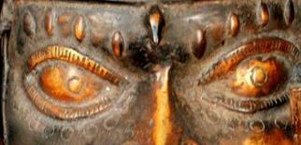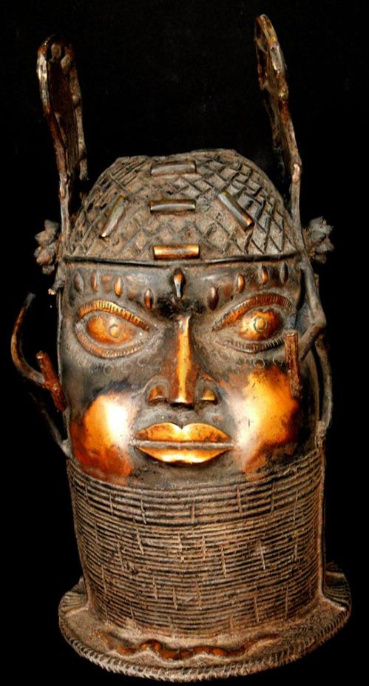



Figs. 1-3.

Case No.: 6

**Accession No.**

**Formal Label:** Afr-Nigeria-Benin-Edo Peoples-Portrait Head of an Oba-Bronze-16th c

**Display Description:**

This is a very complex bronze head from the Edo people. This stylized portrait head depicts a 16th century Oba royal personage at Benin wearing a sophisticated headdress and a distinctive collar reserved for royalty. A complex net of coral beads adorns the head. A high collar, known as *odigba*, also of coral beads reaches the chin.  This portrait accurately depicts the four vertical keloids or scarifications that extend over the eye ridge. Below the eyes are seven circular tattoos. A serpent is placed on the base at the front as a symbol of power. An elephant's tusk would have been placed in the hole in the center of the head so that the natural curve of the tusk would allow it to rest against a wall.

**LC Classification:**

**Date or Time Horizon: 19th c**

**Geographical Area:**

**Map:**

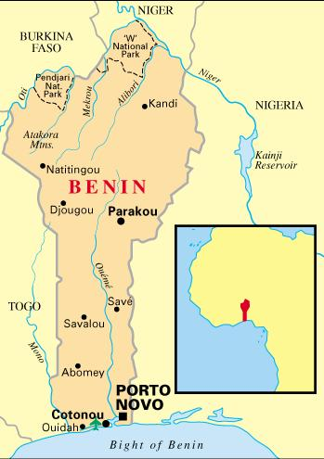



http://www.derreisefuehrer.com/a/main/8f350f44-1a25-476a-9457-1c431cc20c8b/41AF38DE-7933-11DB-9FB2-8F4527C0BFE9/4DC6B502-7933-11DB-8DAC-994FBF05B2D8.gif

**GPS coordinates:**

**Cultural Affiliation:**

**Medium: bronze**

**Weight: 11.13 lbs**

**Dimensions:** 14.173 inches;

**Condition:**

**Provenance:**

**Discussion:**

**References:**

Augustus Pitt-Rivers. 1900. *Antique works of art from Benin: collected by Lieutenant-General Pitt Rivers.* Publisher: London : Privately printed, 1900.

Hagen, K. 1900. Altertumer von Benin, *Jahrbuch der hamburgischen Wissenschaftlichen Anstalten*, V. XVII.

Ling Roth, H. [1968 [1903] *Great Benin, its customs, art and horrors*. London: Routledge & Kegan Paul Ltd.

Dark, P. J. C., W. & B. Foreman. 1960. Benin art. London: Paul Hamlyn..

Dark, P. J.C. 1973. *An Introduction to Benin Art and Technology*. Oxford: At the Clarendon Press.

Ben-Amos, Paula. 1980. *The art of Benin.* New York, N.Y.: Thames and Hudson.

Freyer, Bryna. 1987. *Royal Benin art*. Washington, D.C.: Published for the National Museum of African Art by the Smithsonian Institution Press.

Ezra, Kate. 1992. *Royal art of Benin*, *The Perls collection in the Metropolitan Museum of Art*. New York: Metropolitan Museum of Art : Distributed by H. N. Abrams..

Duchâteau, Armand. 1994. *Benin, Royal art of Africa from the Museum für Völkerkunde, Vienna*. [Houston]: Museum of Fine Arts, Houston ; Munich: Prestel.

